CHAPTER ONE
INTRODUCTION
1.1 BACKGROUND OF THE PROJECT
Online refers to electronic learning, it is the acquisition of knowledge and skill using electronic technologies such as computer and internet-based courseware and local and wide area networks. Distance learning is one of the most dramatic technology-based changes occurring in education today. Communication technology enables learners to receive instruction despite geographic and time disparities that would make traditional classroom instruction impossible.
Distance instruction is learner-centered, that is, it enables learners to tailor the instruction that they are receiving to meet their individual needs. Some distance programs use print media, some use telecommunications, and many use both, but geographic and time separation of the student and the teacher is a fundamental characteristic of distance education. Multimedia instruction with networked computers, video systems, or television may be used to connect the local classroom to learners at a distance. Satellite, compressed video, and fiber-optic systems are increasingly used for same-time, different-place education. This approach is also called synchronous distance learning. Students can also learn at different times and in different places. This approach is called asynchronous distance learning.
Early Screen-class systems, based on Computer Based Learning/Training often attempted to replicate autocratic teaching styles whereby the role of the Screen-class system was assumed to be for transferring knowledge, as opposed to systems developed later based on Computer Supported Collaborative Learning (CSCL), which encouraged the shared development of knowledge.
As early as 1993, Graziadei William described an online computer-delivered lecture, tutorial and assessment project using electronic mail, two VAX Notes conferences and Gopher/Lynx together with several software programs that allowed students and instructor to create a Virtual Instructional Classroom Environment in Science (VICES) in Research, Education, Service & Teaching (REST). In 1997 Graziadei, W. et al, published an article entitled Building Asynchronous and Synchronous Teaching-Learning Environments: Exploring a Course/Classroom Management System Solution. They described a process at the State University of New York (SUNY) of evaluating products and developing an overall strategy for technology-based course development and management in teaching-learning. The product(s) had to be easy to use and maintain, portable, replicable, scalable, and immediately affordable, and they had to have a high probability of success with long-term cost-effectiveness. Today many technologies can be, and are, used in e-learning, from blogs to collaborative software, e-Portfolios, and virtual classrooms. Most e-learning situations use combinations of these techniques.

  - STATEMENT OF THE PROBLEM
Looking around students especially tertiary education suffers a lot of setbacks in external exams due to the primitive nature of teaching system which they receive. They don’t have access to global information hence lacks a huge knowledge of what is obtainable in the society, the library is not equipped with good books and at the same time they don’t have access to internet.
The rate of examination malpractice has increased and attention must be given fast to it before it ruins the education system of the country.
Also, distance is a barrier to some people who seek to be educated.

1.3 AIMS & OBJECTIVES OF THE PROJECT
1. To provide alternative way of attaining education
2. To implement a system which improve school learning system
3. To facilitate the development of information technology
4. To enhance examination, assignments, test and certification of students thereby improving the standard of education.
5. To reveal the use and technology of wireless network to the user.

1.4 SIGNIFICANCE OF THE PROJECT
Screen-class can provide benefits for the organizations and individuals involved.
Improved performance: it is interactive to the students thereby improving their productivity.
Improves standard of education: it improve school learning system that is, students can take online class comfortable while they at home.
Increased access: it enables people from any part of the world to be educated.
Convenience and flexibility to learners: learning process is structured in units; this makes the learner study at his own convenience without getting too bored with lectures.
Reduced cost: it reduces the cost of learning, examination, test, assignments and result processing institutions.

1.5 SCOPE OF THE PROJECT
This project is a tutorial and measurement of performance on wireless network technology. The project is designed using PHP, JAVASCRIPT and MySQL.

1.6 LIMITATIONS OF THE PROJECT
Due to financial constraints, people cannot afford this form of learning and measurement, especially towards the cost of accessing the internet.
Also, the rate of technology is moving at rapid speed and not everybody understands how some of the tools used for this education process are used.

1.7 DEFINITION OF TERMS
Screen-class: learning conducted via electronic media, especially via the Internet.
World Wide Web: World Wide Web simply called www is the most important tool of the Internet.
Web Site: A website is a collection of many interconnected web pages organized by a specific college, organization company etc, containing web pages (good and commodities) on the Internet.
Hyperlinks: Hyperlinks are highlighted words and phrase you find on web documents that you can click on as to jump to some other documents or Internet services.
CHAPTER TWO
LITERATURE REVIEW
By 2006, 3.5 million students were participating in on-line learning at institutions of higher education in the United States. According to the Sloan Foundation reports, there has been an increase of around 12–14 per cent per year on average in enrollments for fully online learning over the five years 2004–2009 in the US post-secondary system, compared with an average of approximately 2 per cent increase per year in enrollments overall. Allen and Seamen (2009) claims that almost a quarter of all students in post-secondary education were taking fully online courses in 2008, and a report by Ambient Insight Research suggests that in 2009, 44 per cent of post-secondary students in the USA were taking some or all of their courses online, and projected that this figure would rise to 81 per cent by 2014. Thus it can be seen that e-learning is moving rapidly from the margins to being a predominant form of post-secondary education, at least in the USA.
Many higher educations, for-profit institutions, now offer on-line classes. By contrast, only about half of private, non-profit schools offer them. The Sloan report, based on a poll of academic leaders, says that students generally appear to be at least as satisfied with their on-line classes as they are with traditional ones. Private institutions may become more involved with on-line presentations as the cost of instituting such a system decreases. Properly trained staff must also be hired to work with students on-line. These staff members need to understand the content area, and also be highly trained in the use of the computer and Internet. Online education is rapidly increasing, and online doctoral programs have even developed at leading research universities.

2.1 APPROCHES TO ONLINE LECTURE & EVALUATION SERVICES
Online lecture and evaluation services have evolved since computers were first used in education. There is a trend to move towards blended learning services, where computer-based activities are integrated with practical or classroom-based situations.
Bates and Poole (2003) and the OECD (2005) suggest that different types or forms of e-learning can be considered as a continuum, from no e-learning, i.e. no use of computers and/or the Internet for teaching and learning, through classroom aids, such as making classroom lecture PowerPoint slides available to students through a course web site or learning management system, to laptop programs, where students are required to bring laptops to class and use them as part of a face-to-face class, to hybrid learning, where classroom time is reduced but not eliminated, with more time devoted to online learning, through to fully online learning, which is a form of distance education. This classification is somewhat similar to that of the Sloan Commission reports on the status of e-learning, which refer to web enhanced, web supplemented and web dependent to reflect increasing intensity of technology use. In the Bates and Poole continuum, 'blended learning' can cover classroom aids, laptops and hybrid learning, while 'distributed learning' can incorporate either hybrid or fully online learning.
It can be seen then that e-learning can describe a wide range of applications, and it is often by no means clear even in peer reviewed research publications which form of e-learning is being discussed. However, Bates and Poole argue that when instructors say they are using e-learning, this most often refers to the use of technology as classroom aids, although over time, there has been a gradual increase in fully online learning.

2.2 COMPUTER BASED LEARNING
Computer-based learning, sometimes abbreviated to CBL, refers to the use of computers as a key component of the educational environment. While this can refer to the use of computers in a classroom, the term more broadly refers to a structured environment in which computers are used for teaching purposes. The concept is generally seen as being distinct from the use of computers in ways where learning is at least a peripheral element of the experience (e.g. computer games and web browsing).

2.3 COMPUTER BASED TRAINING
Computer-Based Trainings (CBTs) are self-paced learning activities accessible via a computer or handheld device. CBTs typically present content in a linear fashion, much like reading an online book or manual. For this reason they are often used to teach static processes, such as using software or completing mathematical equations. The term Computer-Based Training is often used interchangeably with Web-based training (WBT) with the primary difference being the delivery method. Where CBTs are typically delivered via CD-ROM, WBTs are delivered via the Internet using a web browser. Assessing learning in a CBT usually comes in the form of multiple choice questions, or other assessments that can be easily scored by a computer such as drag-and-drop, radial button, simulation or other interactive means. Assessments are easily scored and recorded via online software, providing immediate end-user feedback and completion status. Users are often able to print completion records in the form of certificates.
CBTs provide learning stimulus beyond traditional learning methodology from textbook, manual, or classroom-based instruction. For example, CBTs offer user-friendly solutions for satisfying continuing education requirements. Instead of limiting students to attending courses or reading printing manuals, students are able to acquire knowledge and skills through methods that are much more conducive to individual learning preferences. For example, CBTs offer visual learning benefits through animation or video, not typically offered by any other means.
CBTs can be a good alternative to printed learning materials since rich media, including videos or animations, can easily be embedded to enhance the learning. Another advantage to CBTs is that they can be easily distributed to a wide audience at a relatively low cost once the initial development is completed.
However, CBTs pose some learning challenges as well. Typically the creation of effective CBTs requires enormous resources. The software for developing CBTs (such as Flash or Adobe Director) is often more complex than a subject matter expert or teacher is able to use. In addition, the lack of human interaction can limit both the type of content that can be presented as well as the type of assessment that can be performed. Many learning organizations are beginning to use smaller CBT/WBT activities as part of a broader online learning program which may include online discussion or other interactive elements.

2.4 COMPUTER SUPPORTED COLLABORATIVE LEARNING (CSCL)
Computer supported collaborative learning (CSCL) is one of the most promising innovations to improve teaching and learning with the help of modern information and communication technology. Most recent developments in CSCL have been called e-learning 2.0, but the concept of collaborative or group learning whereby instructional methods are designed to encourage or require students to work together on learning tasks has existed much longer.
In Datacloud: Toward a New Theory of Online Work, Johndan Johnson-Eilola describes a specific computer-supported collaboration space: The Smart Board. According to Johnson-Eilola, a “Smart Board system provides a 72-inch, rear projection, touchscreen, intelligent whiteboard surface for work”. In Datacloud, Johnson-Eilola asserts that “we are attempting to understand how users move within information spaces, how users can exist within information spaces rather than merely gaze at them, and how information spaces must be shared with others rather than being private, lived within rather than simply visited”. He explains how the Smart Board system offers an information space that allows his students to engage in active collaboration. He makes three distinct claims regarding the functionality of the technology:
1) The Smart Board allows users to work with large amounts of information,
2) It offers an information space that invites active collaboration,
3) The work produced is often “dynamic and contingent”. Johnson-Eilola further explains that with the Smart Board “…information work becomes a bodied experience”. Users have the opportunity to engage with inhabit the technology by direct manipulation. Moreover, this space allows for more than one user; essentially, it invites multiple users.

2.5 TECHNOLOGY ENHANCED LEARNING (TEL)
Technology enhanced learning (TEL) has the goal to provide socio-technical innovations (also improving efficiency and cost effectiveness) for e-learning practices, regarding individuals and organizations, independent of time, place and pace. The field of TEL therefore applies to the support of any learning activity through technology.
Along with the terms learning technology, instructional technology, and Educational Technology, the term is generally used to refer to the use of technology in learning in a much broader sense than the computer-based training or Computer Aided Instruction of the 1980s. It is also broader than the terms Online Learning or Online Education which generally refer to purely web-based learning. In cases where mobile technologies are used, the term M-learning (Mobile-learning) has become more common. E-learning, however, also has implications beyond just the technology and refers to the actual learning that takes place using these systems.
E-learning is naturally suited to distance learning and flexible learning, but can also be used in conjunction with face-to-face teaching, in which case the term Blended learning is commonly used. E-Learning pioneer Bernard Luskin argues that the "E" must be understood to have broad meaning if e-Learning is to be effective. Luskin says that the "e" should be interpreted to mean exciting, energetic, enthusiastic, emotional, extended, excellent, and educational in addition to "electronic" which is a traditional national interpretation. This broader interpretation allows for 21st century applications and brings learning and media psychology into the equation.
In higher education especially, the increasing tendency is to create a Virtual Learning Environment (VLE) (which is sometimes combined with a Management Information System (MIS) to create a Managed Learning Environment) in which all aspects of a course are handled through a consistent user interface standard throughout the institution. A growing number of physical universities, as well as newer online-only colleges, have begun to offer a select set of academic degree and certificate programs via the Internet at a wide range of levels and in a wide range of disciplines. While some programs require students to attend some campus classes or orientations, many are delivered completely online. In addition, several universities offer online student support services, such as online advising and registration, e-counseling, online textbook purchase, student governments and student newspapers.
Screen-class can also refer to educational websites such as those offering learning scenarios, worksheets and interactive exercises for children. The term is also used extensively in the business sector where it generally refers to cost-effective online training.
The recent trend in the e-learning sector is screencasting. There are many screencasting tools available but the latest buzz is all about the web based screencasting tools which allow the users to create screencasts directly from their browser and make the video available online so that the viewers can stream the video directly. The advantage of such tools is that it gives the presenter the ability to show his ideas and flow of thoughts rather than simply explain them, which may be more confusing when delivered via simple text instructions. With the combination of video and audio, the expert can mimic the one on one experience of the classroom and deliver clear, complete instructions. From the learner's point of view this provides the ability to pause and rewind and gives the learner the advantage of moving at their own pace, something a classroom cannot always offer.

CHAPTER THREE
DESIGN METHODOLOGY
3.1 OVERVIEW OF THE PROPOSED SYSTEM
At this stage, the information gathered were analyzed and restructured into a more relevant and useful data. Data analysis and restructuring was based on the identification of the basic needs and the structure required for the project. The information gathered were that the analyzed and restructured in such a way that the subsystems and the modules were achieved efficiently. The analysis and restructuring of these data were such that the system is capable of presenting one frame at a time to the user.
This Screen-class system is a system that has some learning facilities, which aids the learner in using the package. It also contains facilities for test of knowledge. The subsystems and the module in this software were integrated to make up the topic itself.

3.1.1 METHOD OF DATA COLLECTION
Having achieved the software requirements, the next step was to source for information relative to the subject. This process of information gathering was achieved through so many sources including:
- File downloads from the Internet
- Textbooks in the library
- Newspaper, Journals and articles
- Other publications
- Personal observations.

3.1.2 OBJECTIVE OF THE EXISTING SYSTEM
The objective of the system is to develop an online lecture and evaluation system that will aid in online teaching to students.

Homepage

Admin login
Super Admin login

Fig 3.1 information flow chart
Add Class
View Students
Upload Materials
Add student
Add staff

Add
Faculty,
Department, course

Assign course for administrators
Take attendance

Student login

Take class
Watch video & Read note
Start quiz

FIGURE: 1.1 OBJECTIVE OF THE EXISTING SYSTEM
3.1.3 INPUT ANALYSIS
The input to the new system is student’s login form, student’s forum dialogue space, question setting form, and answer form. These forms are captured online and contain details of the user, the questions and answers.

3.1.4 PROCESS ANALYSIS
The answer supplied by the user is processed by accessing their scores, and storing it on the database and the class forum with is interactive in nature.

3.1.5 OUTPUT ANALYSIS
The output from the system is the scores of the test and the reply to questions in the class forum. The screen-class system also forms part of the output.

3.1.6 PROBLEM OF THE CURRENT SYSTEM
Without screen-class, it will be difficult for people to learn fast. Experts are not readily available, so there is need to have a knowledge based system that can be used to train students in various fields of learning.

3.1.7 JUSTIFICATION FOR THE NEW SYSTEM
Online lecture and evaluation system can provide benefits for the organizations and individuals involved. It provides students with the opportunity to learn fast and have a wide knowledge. Internet access makes learning easy, obtainable, and affordable.

3.1.8 DATA PROCESSING
Data processing involves the manipulation and processes involved in displaying the class, past question, test for the student for download. These processes start from the school administrators, follow by administrator’s (staff) to the student. All resources are uploaded to the system by the admin into the system where the student can search for a desired past question or input the details of the past question they need from the system. All vital records are stored in the database for future purpose. All the processes are being strictly authenticated and validated to ensure data integrity.

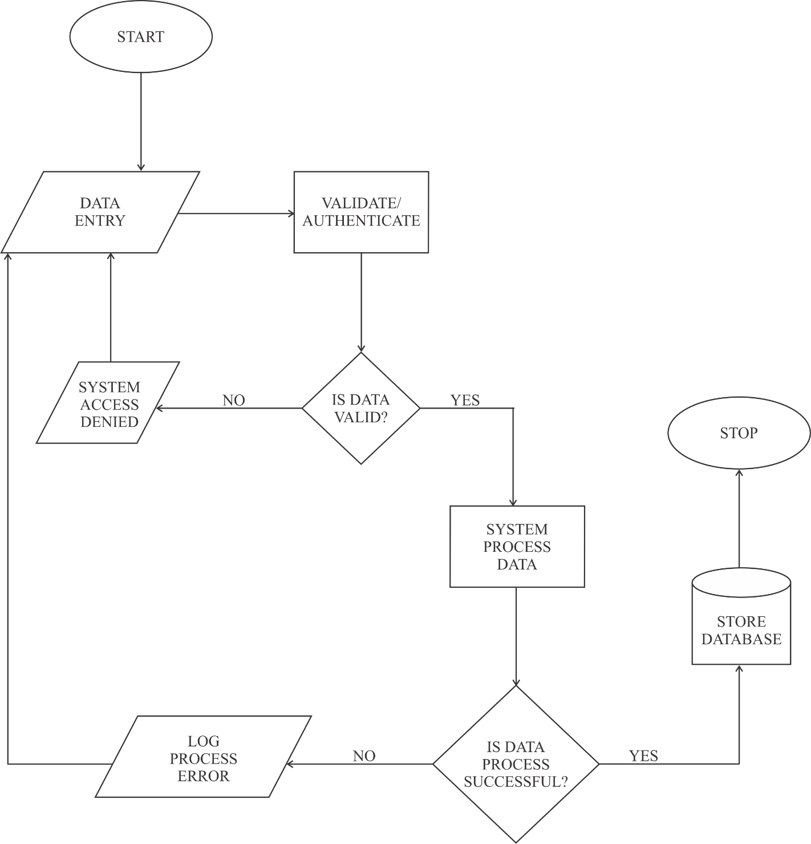

FIGURE: 1.2 FLOW OF DATA IN DATA PROCESSING MODULE
3.2 SYSTEM ARCHITECTURE
Below is the application architecture which shows a graphical representation of the application, views, and database. It also shows the connections and interactions that can be carried out in the system.

SUPER ADMIN PORTAL

ADMIN PORTAL

STUDENT PORTAL

HOME PAGE
HOME PAGE

HOME PAGE

SUPER ADMIN LOGIN
ADMIN LOGIN

STUDENT LOGIN

DATA PROCESSING & STORAGE

REGISTER &VIEW STAFF
ADD TOPIC

TAKE CLASS

DATABASE

ADD CLASS

REGISTER &VIEW STUDENT

UPLOAD MATERIALS

UPLOAD MATERIALS

REGISTER & VIEW FACULTY

TAKE ATTENDANCE

TAKE ATTENDANCE

REGISTER & VIEW COURSE

ASSIGN COURSE FOR LLECTURER

FIGURE: 1.3 SYSTEM ARCHITECTURE
3.3 SYSTEM FLOWCHART
START

START
START

SUPER ADMIN LOGIN
STUDENT LOGIN

ADMIN LOGIN

NO
LOGIN SUCCESSFUL
LOGIN SUCCESSFUL

LOGIN SUCCESSFUL

NO NO

YES YES YES
VIEW STAFF, STUDENT, FACULTY, COURSE
TAKE CLASS

ADD TOPIC, CLASS

DOWNLOAD MATERIAL

TAKE ATTENDANCE

ALLOCATE COURSE

UPLOAD MATERIAL

TAKE ATTENDANCE

STOP

FIGURE: 1.4 SYSTEM FLOWCHART
CHAPTER FOUR
SYSTEM IMPLEMENTATION AND DESIGN
  - DESIGN STANDARDS
The new system is structured to work with the standard software development procedures. It is web based and has a relational database structure for storing the various activities involved. The screen-class system is placed in PHP & JAVASCRIPT codes for online access alongside with MySQL database.

    - THE HOME PAGE DESIGN
The home page output from the system. These pages contains super administrator, administrator and student to login into their portal.


FIGURE: 1.5 HOME PAGE DESIGN

    - AUTHENTICATION MANAGEMENT
Every user who wants to use this software (screen-class) by means of email address and password which is already created by the super administrator and is stored in the database. This authentication module can only access administrator and student who has register under administrator portal. This authentication form is required email as username and password.

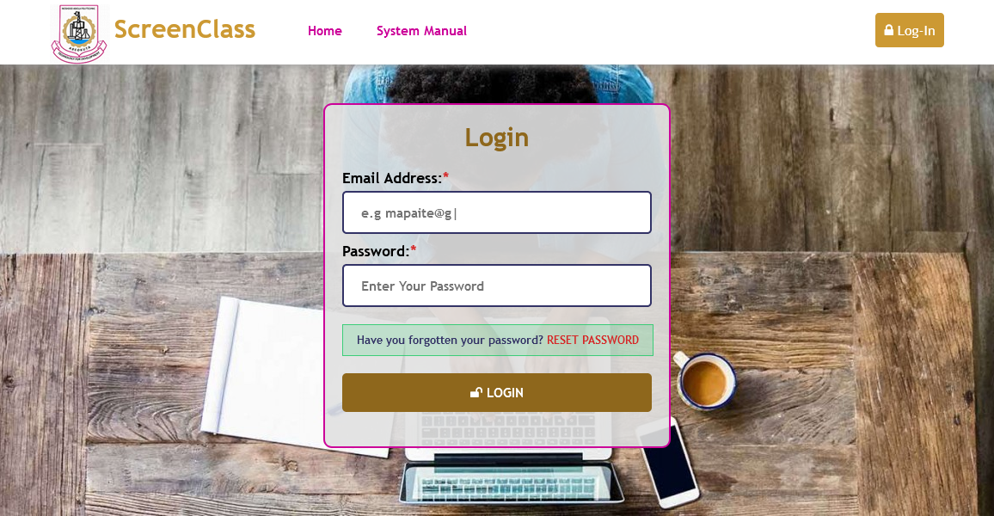

FIGURE: 1.6 AUTHENTICATION MANAGEMENT

4.1.3 THE SUPER ADMIINSTRATOR’S DASHBOARD PORTAL
The super administrators are the back-end of the software, they are the one who manage and manipulate every module in this page. They can register administrators as (staff), students, add departments, add courses. Also they can assign course for staff and manipulate staff (update staff profile) and (update student profile).

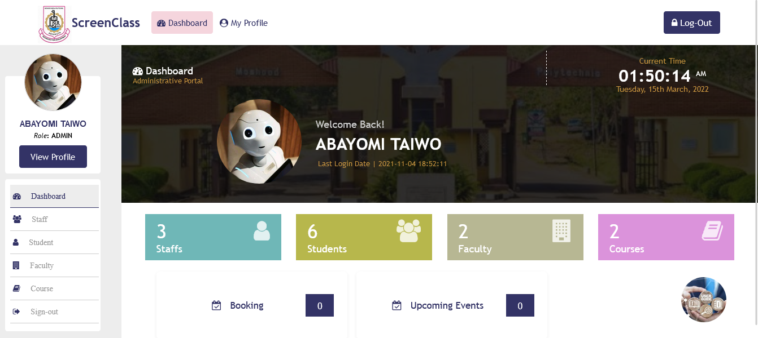

FIGURE: 1.7 SUPER ADMINSTRATOR’S DASHBOARD

4.1.4 ADMINSTRATOR’S REGISTRATION
Any administrators, student want to make use of this software (screen-class) he/she must register under super administrators. Every registration automatically the system will generate identity no for administrators (staff id no) and student (matric no) so that the system can count number of administrators and student that are registered.
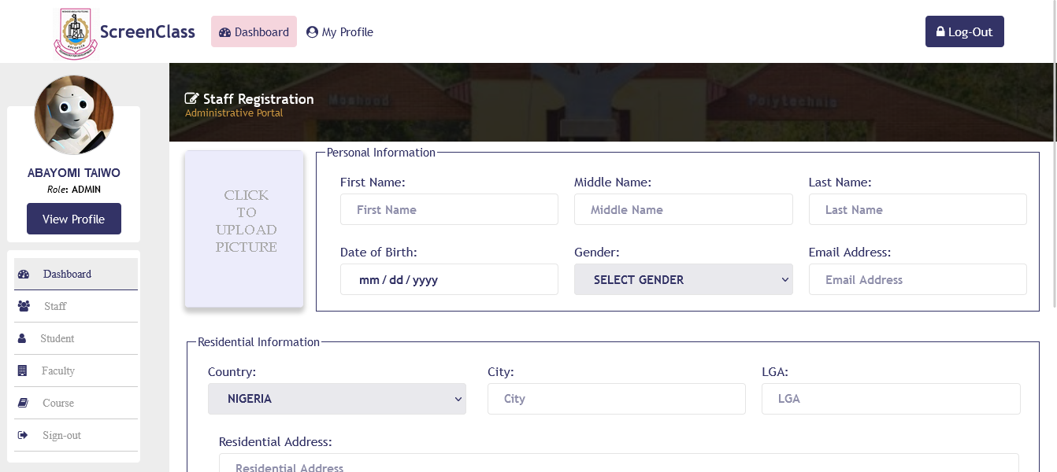

FIGURE: 1.8 ADMINSTRATOR’S REGISTRATION
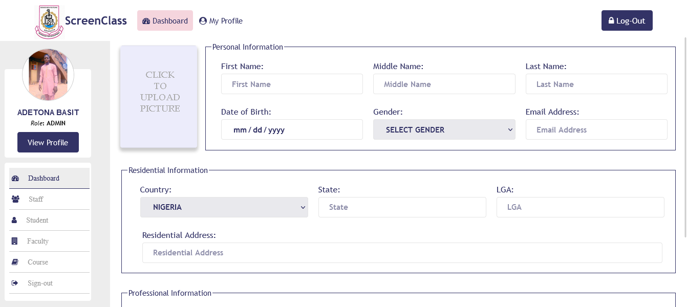

FIGURE: 1.9 STUDENT REGISTRATION

4.1.5 THE ADMINSTRATOR’S DASHBOARD PORTAL
The Administrator’s portal are staff that are registered under super administrators. The software carry operation like, registered administrators (staff) can view students, add class, take lecture, and as well, it can upload materials for students and take student attendance.

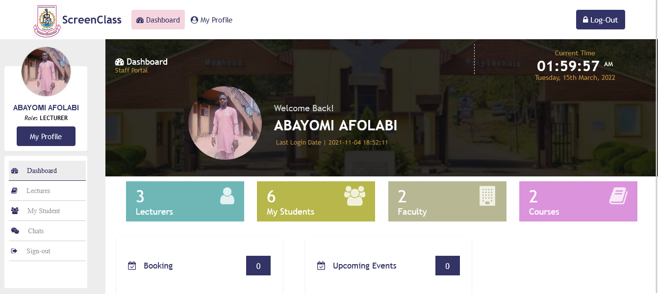

FIGURE: 1.10 ADMINSTRATOR’S DASHBOARD
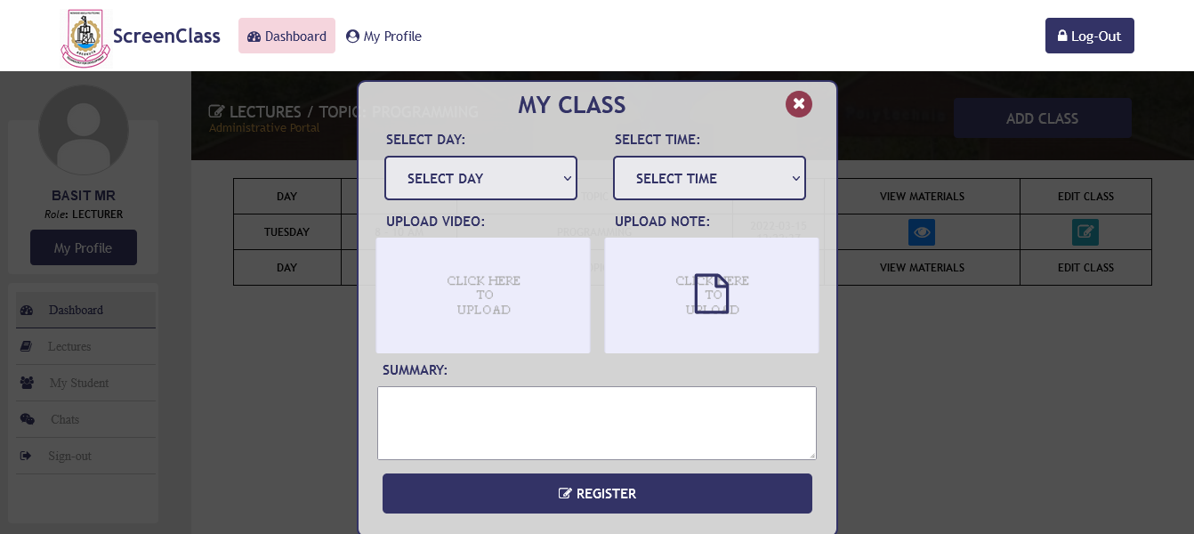

FIGURE: 1.11 ADMINSTRATOR’S CLASS

4.1.6 THE STUDENT DASHBOARD PORTAL
A student that has registered under school administrators (super administrators) can only access and login to his/her portal. In this dashboard, student can take class if super administrators has assign course for any of the lecturer (staff) and can allow to take class for the student.
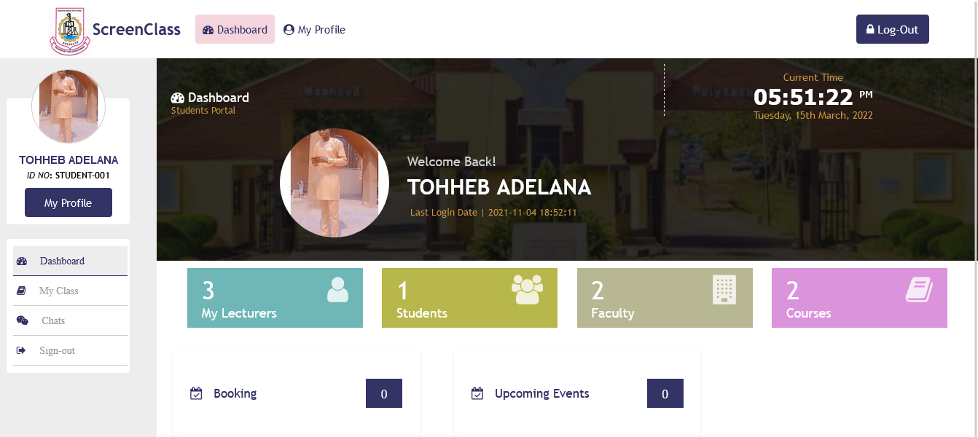

FIGURE: 1.12 STUDENT DASHBOARD

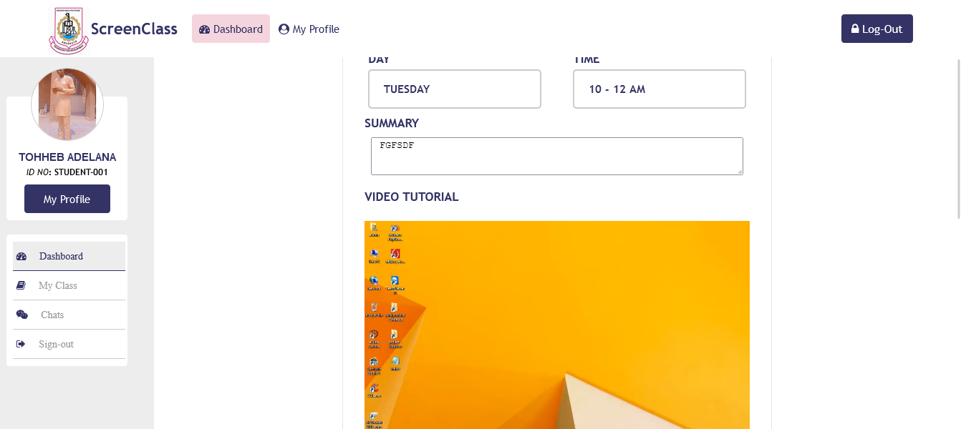

FIGURE: 1.13 STUDENT DOWNLOADABLE MATERIALS

4.1.7 DATABASE DESIGN
MySQL database was used in the design. There are ten tables used in the design. The student table, staff table, course table, department table, faculty table, counter table, lectures table, week table, status table, period table.

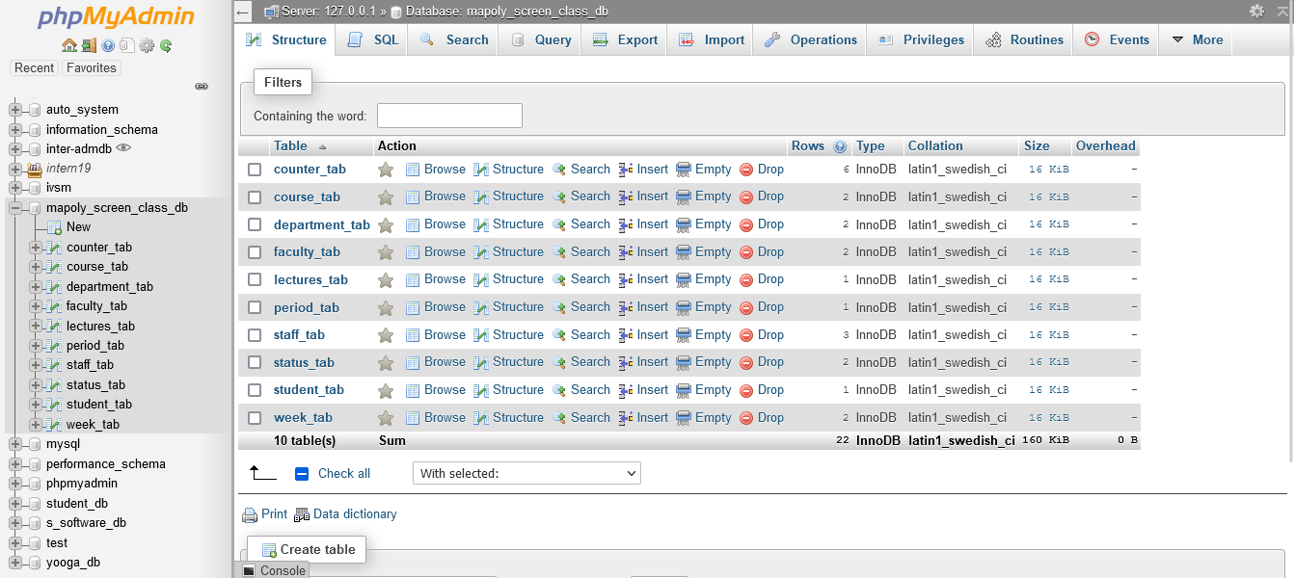

FIGURE: 1.14 DATABASE DESIGN

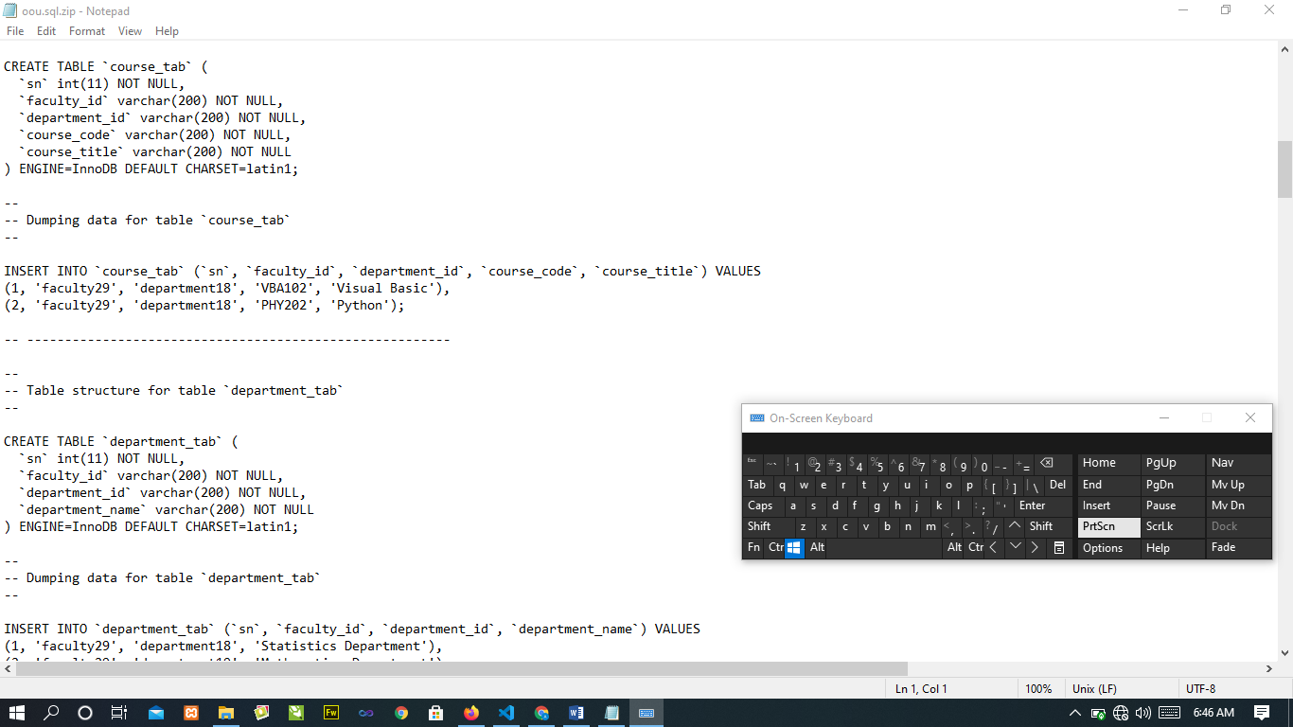

FIGURE: 1.15 MYSQL DATABASE DESIGN

4.2 SYSTEM REQIREMENT

Hardware Requirements

In the design, the software developed needs the following hardware for an effective and efficient operation of the new system.

Intel Computer System.
- At least 2GB RAM.
- Enhanced keyboard.
- At least 320GB hard disk.
- A colored monitor.
- An uninterruptible power supply (UPS) units
- LaserJet or DeskJet printer.

Software Requirements
The software requirements include: -
1. A window XP or higher version for faster processing
- Database server (apache)
- Web server (apache)
- Graphical application (Corel draw)
- Dreamweaver 8.0
- Mozilla web browser
- Fire Fox web browser
- Chrome web browser

Operational Requirement
For the new system to be operational, Internet access is needed in the computer.
Personnel Requirement
A Computer system with internet access.

CHAPTER FIVE
SUMMARY, CONCLUSION AND RECOMMENDATIONS
5.1 SUMMARY
Having come to the completion of the project work, a lot of achievements was made and they include:
- Design and development of a school online lecture and evaluation system.
- To view list of administrator’s and student was also design.
- Question setting system was also designed.
- To add faculty, department, course, class was also design.
- To upload and view downloadable materials was also design
- Answer system was equally designed to enable the students supply their answers to questions.
- The use of PHP, JAVASCRIPT, CSS codes to design a web application.
- The use of a database server was implemented.

5.2 CONCLUSION
With the advent of information technology in our developing and developed world, learning facilities are now on the increase. Also means of accessing the understanding rate is also fast increasing. Therefore, the online lecture and evaluation system as developed in this project will assist the users to test the knowledge of people around.
This adds a lot of advantage to the communication / training institutes as a package like this can be used to train the students online and test their knowledge and also adds value to education standard as it reduces examination malpractices.

5.3 RECOMMENDATION
Online lecture and evaluation system is recommended to all who wants to be educated especially at the tertiary level as it is effective and of high standards.

REFERENCES

A, B. (2005). e-Learning and Distance Education. London: Oxford university press.
Allen, I. a. (2009). Online Education in the United States. New Jersey. Wiley publishing.
Edward. (2000). E-Learning Designing. Brussels: Sams publishing.
Graziadei. (1993). Virtual Instructional Classroom Environment in Science (VICES). Atlanta: Hila press.

Harasim, L. (1995). A Field Guide to Teaching and Learning Online. Cambridge: MIT Press.

Hebert. (2007). Five Challenges and Solutions in Online Music Teacher. London: Oxford university press.

Hiltz, S. (1990). Evaluating the Virtual Classroom. New York: St. Martin’s press.

Karrer, T. (2008). Corporate Long Tail Learning and Attention Crisis. California: Sun Microsystems, Inc.

Kerkman, L. (2004). Convenience of Online Education Attracts Midcareer. Students. Cambridge: MIT Press.

Mason. R, a. K. (1989). Computers and Distance Education. London: Oxford university press.

Means, B. T. (2009). Evaluation of Evidence-Based. Practices in Online Learning. USA: McGraw Hill companies.

Allen, I. and Seaman, J. (2009). Online Education in the United States. New Jersey: Wiley publishing.

Allen, I. and Seaman, J. (2003). The Quality and Extent of Online Education in the United States. New Jersey: Wiley publishing.
Bates, A. (2005). e-Learning and Distance Education. London: Oxford university press.
Edward, C. (2000). E-Learning Designing. Brussels: Sams publishing.
A cademy, S. (2013). Post-Utme-Questions-Answers-Baze-University. Samphina academy.

Academy, V. (2009). The History of Online Schooling. Visual Academy.
Connection’s. (2016). Main Benefits of Online School . Connection’s Academy.
Docsity. (2013). Exam Study and Advantages of Exampapers. Docsity.
James, A. (2014). Automated Students Management System. Oracle.
K., A. S. (2012). Student Management System.
Ngoma, S. (2019). Effectiveness of PastQuestion.
point, T. (2016). Tutorials point. Retrieved from https://www.tutorialspoint.com/sdlc/sdlc_agile_model.htm.
S., W. S. (2014). A Framework for Web-based Past Question System.
Spinuzzi, C. (2015). The methodology of participatory design. Technical communication.
UNESDOC. (2016). Digital Library. UNESDOC.
University, B. (2019). Exam Past Questions. Baze University.
University, N. e. (2020). Benefits of Online Learning. North eastern University.
Vecchioli, L. (2018). A Process for Evaluating Past Question.
Wayman, J. S. (2015). Software Enabling School Improvement through Analysis of Student Data.

Harasim, L. Hiltz, S. et al (1995). A Field Guide to Teaching and Learning Online. Cambridge: MIT Press.
APPENDIX
HOME PAGE SOUCE CODE

<!DOCTYPE html>
<html>
<head>
<title>MAPOLY - ScreeClass</title>
<?php include 'reference.php' ?>
</head>
<body>
<?php include 'header.php' ?>

<div class="background-image-div">
<?php include 'slide.php' ?>
</div>

<footer>
<div class="overlay-div animated animated zoomIn animated">
<a href="login.php"><button class="main-btns no-right">ADMIN</button></a>

<a href="login.php"><button class=" btn-cl">SUPER ADMIN</button></a>
<a href="login.php"><button class="main-btns no-right">STUDENT</button></a>
</div>
</footer>

</body>
</html>
ADMIN PAGE SOUCE CODE

!DOCTYPE html PUBLIC "-//W3C//DTD XHTML 1.0 Transitional//EN" "http://www.w3.org/TR/xhtml1/DTD/xhtml1-transitional.dtd">
<html lang="en" xmlns="http://www.w3.org/1999/xhtml">
<head>
<?php require_once ("reference.php")?>
<title>Administrative Portal | MAPOLY - ScreenClass</title>

</head>
<body
<?php include 'header.php' ?>
<div class="dashboard-main-div">
<?php include 'admin-reference.php' ?>
<div class="right-sided-div">
<div class="bg-image-div">
<div class="bg-cover">
<div class="dashboard-overall">
<div class="dashboard-admin-text">
<span class="dashboard">
<i class="fa fa-dashboard"></i>
Dashboard
</span>
<br/>
<span class="admin-portal">
Administrative Portal
</span>
</div>

<div class="current-time">
<span class="text">
Current Time
</span><br/>
<span class="time" id="datetime">
<?php echo date("h:i:s") ?> <sup> <?php echo date("A") ?> </sup>
</span><br/>
<span class="text">
<?php $date = date("l, dS F, Y");
echo $date
?>
</span>
</div>
<div class="user-details">
<div class="picture-div">
<img id="ImageDisplay" name="ImageDisplay" alt="Passport"
<?php
if ($passport == ''){
?>
src="images/po.png"
<?php
}else{
?>
src="../admin/staff-picture/<?php echo $passport ?>"
<?php } ?>
>
</div>
<div class="welcome-text">
Welcome Back!
<h1><?php echo $lastname ?> <?php echo $firstname ?></h1>
<span class="login-date"><i class="fa fa-clock"></i>
Last Login Date
<span> | </span>
2021-11-04 18:52:11
</span>
</div>
</div>
</div>
</div>
</div>
<div class="main-displayed-div">
<a href="staff-list.php"><div class="main-div-proper staffs">
<div class="inner-div">
<?php
$staff_count_query = mysqli_query ($conn,"SELECT * FROM `counter_tab` WHERE counter_id='STAFF'") or die ('cannot select staff table');
$staff_count=mysqli_fetch_array($staff_count_query);
$staff=$staff_count['counter_value'];
?>
<i class="fa fa-user"></i>
<span class="number">

<?php echo $staff ?>
</span><br/>
Staffs
</div>
</div></a>
<div class="main-div-proper students" onclick="_view_student()">
<div class="inner-div">
<?php
$staff_count_query = mysqli_query ($conn,"SELECT * FROM `counter_tab` WHERE counter_id='STUDENT'") or die ('cannot select staff table');
$staff_count=mysqli_fetch_array($staff_count_query);
$student=$staff_count['counter_value'];
?>
<i class="fa fa-users"></i>
<span class="number">
<?php echo $student ?>
</span><br/>
Students
</div>
</div>
<a href="faculty-table.php"><div class="main-div-proper faculties">
<div class="inner-div">
<?php
$staff_count_query = mysqli_query ($conn,"SELECT * FROM `counter_tab` WHERE counter_id='FACULTY'") or die ('cannot select staff table');
$staff_count=mysqli_fetch_array($staff_count_query);
$faculty=$staff_count['counter_value'];
?>
<i class="fa fa-building"></i>
<span class="number">
<?php echo $faculty ?>
</span><br/>
Faculty
</div>
</div></a>

<div class="main-div-proper courses" onClick="_view_course();">
<div class="inner-div">
<?php
$staff_count_query = mysqli_query ($conn,"SELECT * FROM `counter_tab` WHERE counter_id='COURSE'") or die ('cannot select staff table');
$staff_count=mysqli_fetch_array($staff_count_query);
$courses=$staff_count['counter_value'];
?>
<i class="fa fa-book"></i>
<span class="number">
<?php echo $courses ?>
</span><br/>
Courses
</div></div> </div>
</body>
</html>

